**Orange_Boba_Shops Changelog:**

04/20/25

* Added “Name of Shop” Column
* Added “Most Expensive Drink” and “Least Expensive Drink” Columns
* Added “Average Drink Cost” Column, with calculations for the average between the Most and Least Expensive drink costs.
* Added Column “Contact Info”, “City”
* Added “Most Expensive Food” and “Least Expensive Food” Columns
* Added “Average Food Cost” Column, with calculations for the average between the Most and Least Expensive Food costs.
* Input Food and Drink costs into Database
* Added “Rating” Column

4/21/25

* Added “# of Review” Columns
* Added “Open” and “Close” Columns
* Added “Address Column”
* Updated Existing Food and Drink Costs columns

4/23/25

* Alterations to actual spreadsheet
  + Changed Names to camel case (e.g. Least Expensive Drink ->cheapestDrink)
  + Omitted Contact information for coding purposes
  + Omitted all of the empty rows
  + Made a new sheet for flavors, to keep track of original drink titles, but omitted them in actual dataset.
  + Replaced full drink titles with main flavors of drink

4/24/25

* Made a new R package: installed tidyverse and ggplot2
* Imported Boba_Shops as a csv:

library(readr)

boba_Shops <- read_csv("boba_Shops.csv")

View(boba_Shops)

Used the following code to make a graph for the reviewNum and the Rating: **ggplot(boba_Shops) +geom_point(mapping=aes(x=rating, y=reviewNum))**

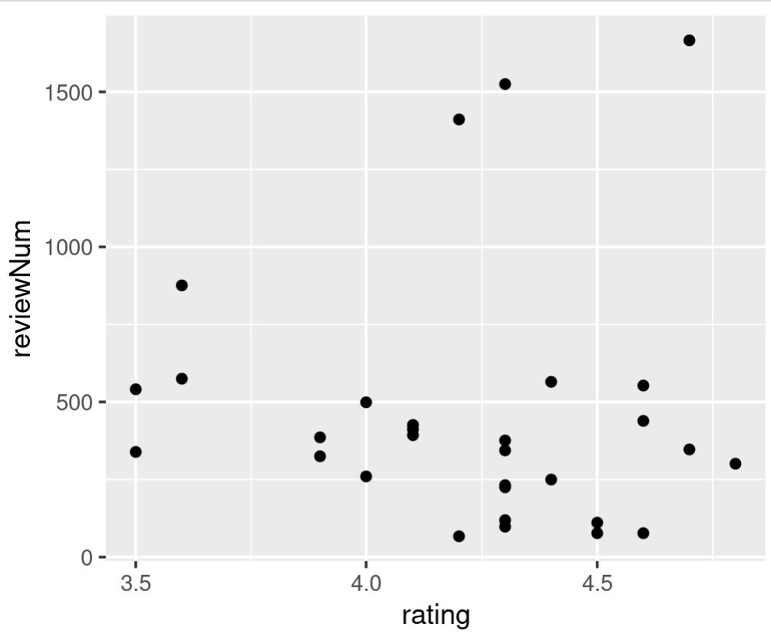

Used the following code to make a graph showing the frequent open times.

ggplot(boba_Shops) +geom_bar(mapping=aes(openTime))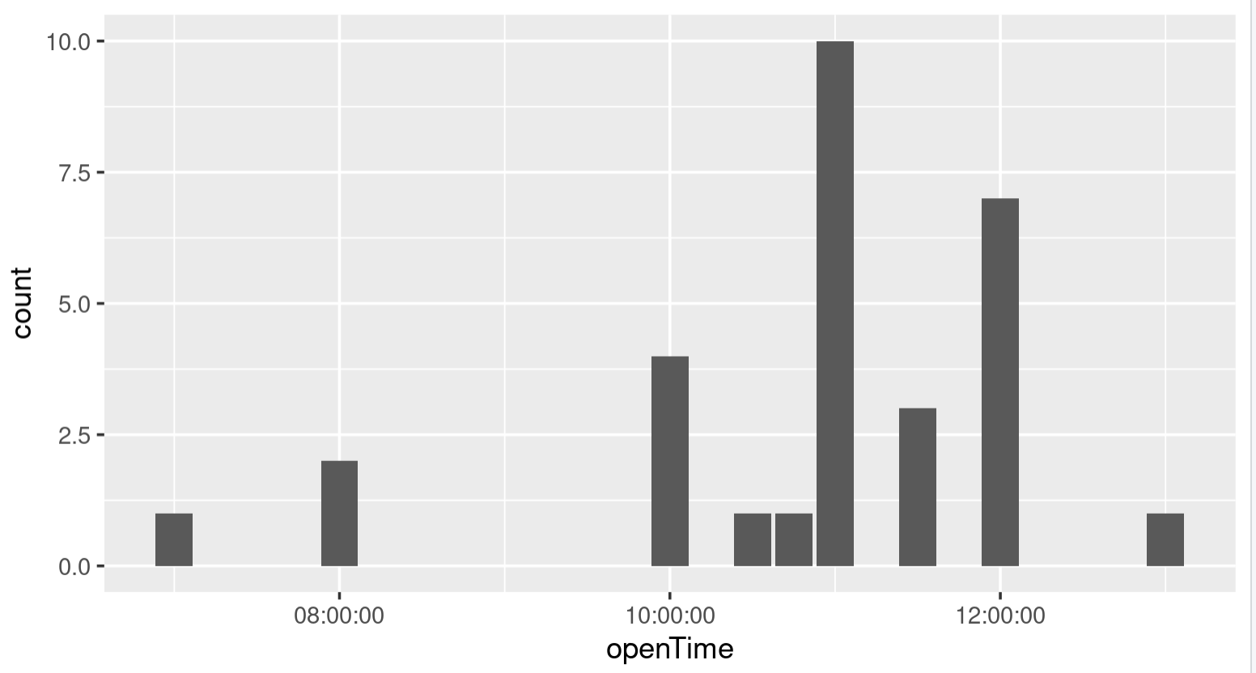

Used the following code to make a graph showing the frequent closing times.

**ggplot(boba_Shops) +geom_bar(mapping=aes(closeTime))**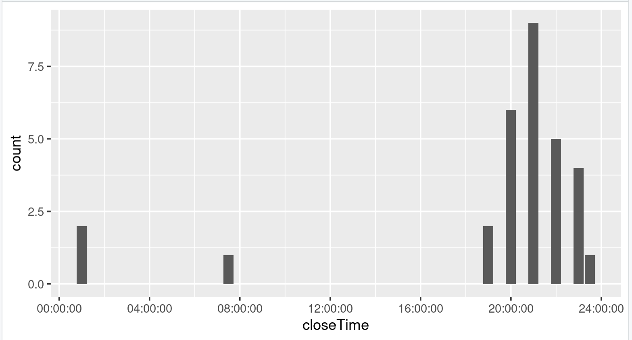

4/25/25:

Used the following code to make a scatterplot of the least expensive drink costs:

boba_Shops$y_values <- seq(from = 1.00, to = 15.50, by = 0.5)

ggplot(boba_Shops)+geom_point(mapping=aes(x= cheapestDrink, y=y_values))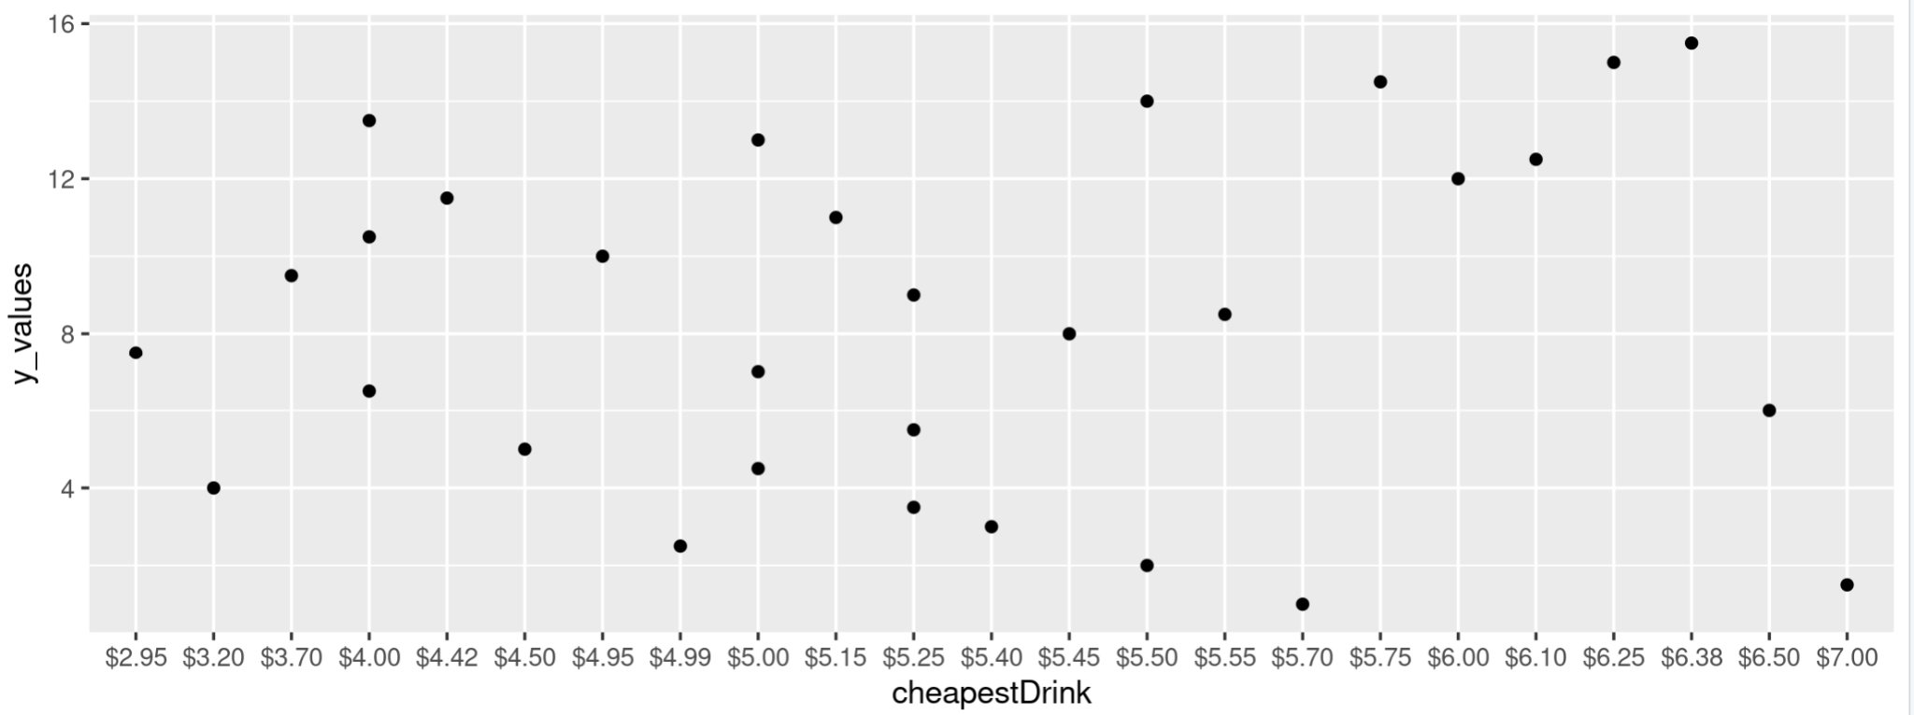

*<https://r-graph-gallery.com/275-add-text-labels-with-ggplot2.html>

Used the following code to make a scatterplot of the most expensive drink costs:

boba_Shops$y_values <- seq(from = 1.00, to = 15.50, by = 0.5)

ggplot(boba_Shops)+geom_point(mapping=aes(x=expensiveDrink, y=y_values))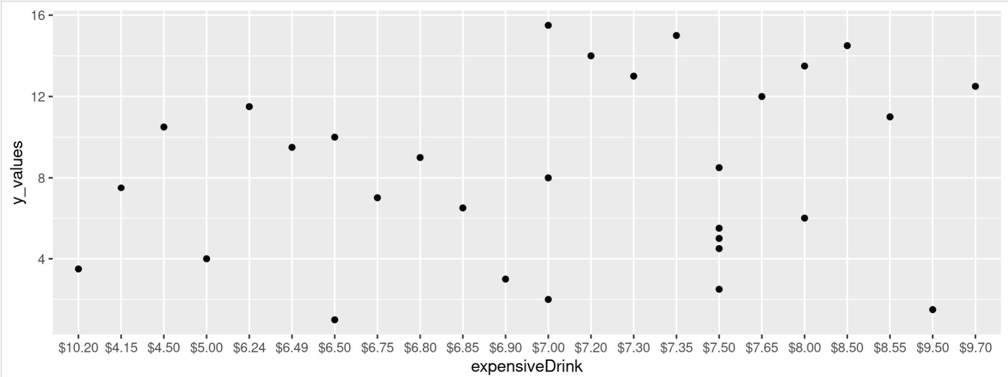

Used the following code to make a scatterplot of the most expensive drink costs:

boba_Shops$y_values <- seq(from = 1.00, to = 15.50, by = 0.5)

ggplot(boba_Shops)+geom_point(mapping=aes(x=drinkAvg, y=y_values))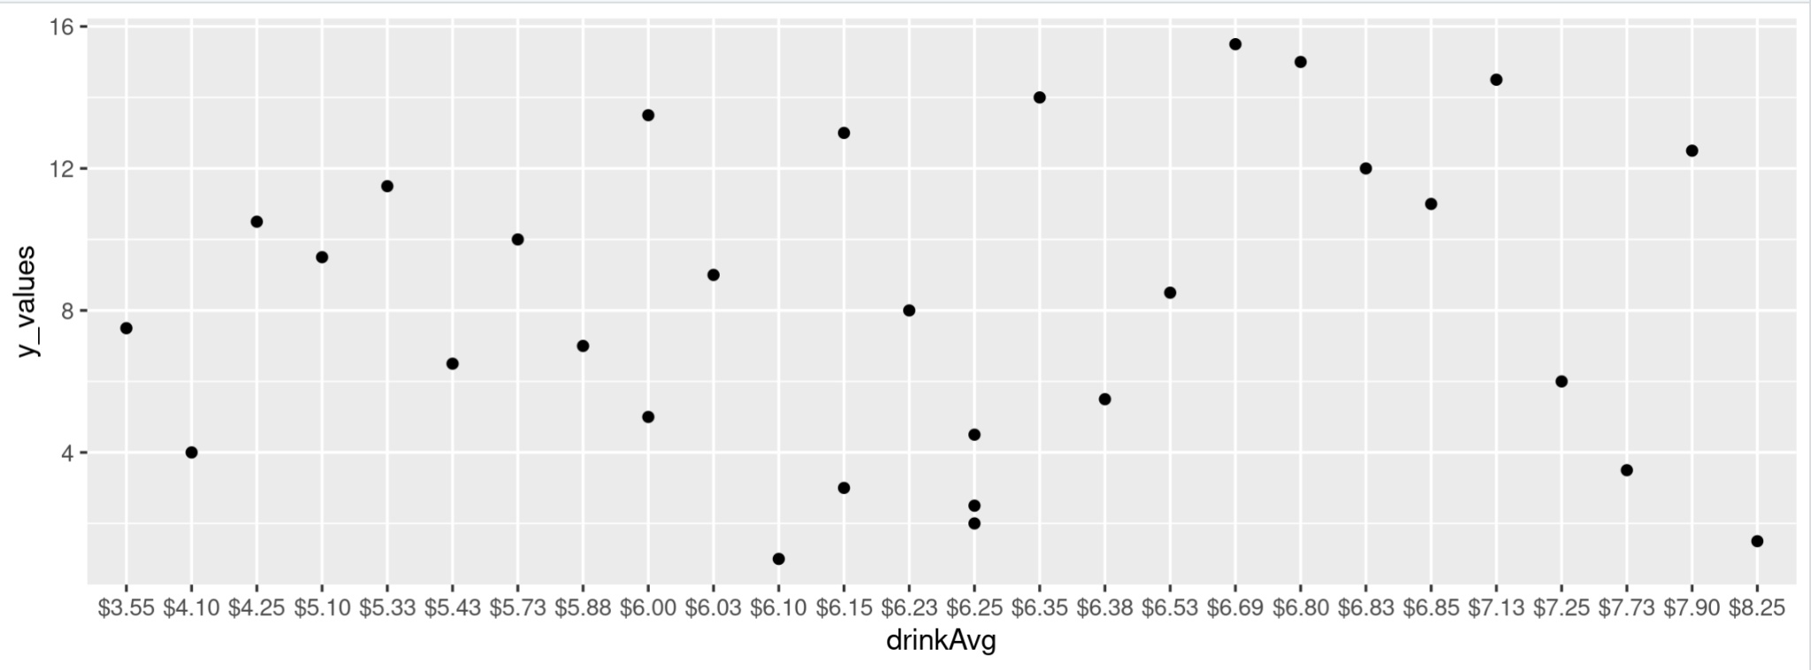

Used the following code to make a scatterplot of the average drink costs:

**boba_Shops$y_values <- seq(from = 1.00, to = 15.50, by = 0.5)**

**ggplot(boba_Shops)+geom_point(mapping=aes(x=drinkAvg, y=y_values))**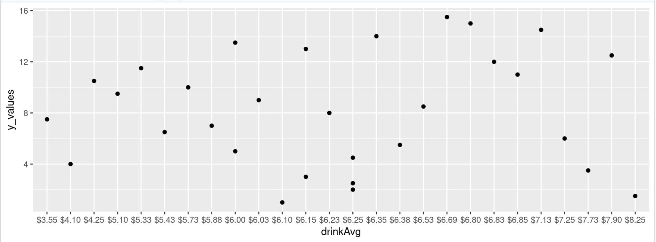

Adjusted cheapest drink scatterplot to have more labels:

* Adjusted y_values to be more clear
* Added labels

ggplot(boba_Shops)+geom_point(mapping=aes(x= cheapestDrink, y=y_values))+labs(title = 'Scatterplot of Cheapest Drinks', subtitle = 'Sample of 30 Boba Shops in the Cities of: Orange, Santa Ana, Garden Grove', caption = 'Data Collected by Chelsea Nanasca from public Yelp databases')

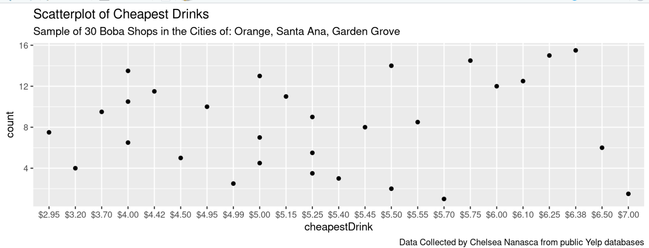

Adjusted most expensive drink scatterplot to have more labels:

**ggplot(boba_Shops)+geom_point(mapping=aes(x= expensiveDrink, y=count))+labs(title = 'Scatterplot of Most Expensive Drinks', subtitle = 'Sample of 30 Boba Shops in the Cities of: Orange, Santa Ana, Garden Grove', caption = 'Data Collected by Chelsea Nanasca from public Yelp databases')**

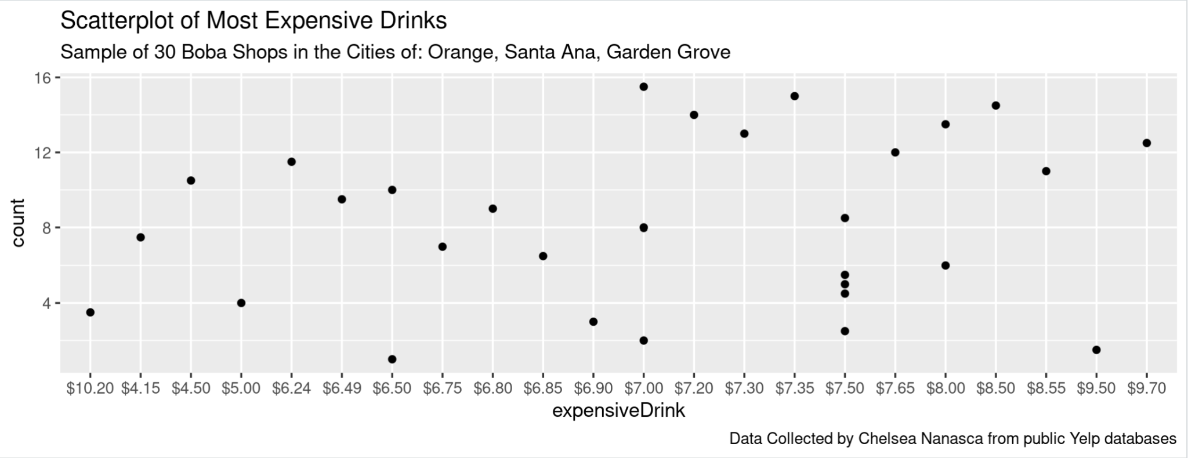

Adjusted the average drink scatterplot to have more labels:

**ggplot(boba_Shops)+geom_point(mapping=aes(x= drinkAvg, y=count))+labs(title = 'Scatterplot of Average Drink Prices', subtitle = 'Sample of 30 Boba Shops in the Cities of: Orange, Santa Ana, Garden Grove', caption = 'Data Collected by Chelsea Nanasca from public Yelp databases')**

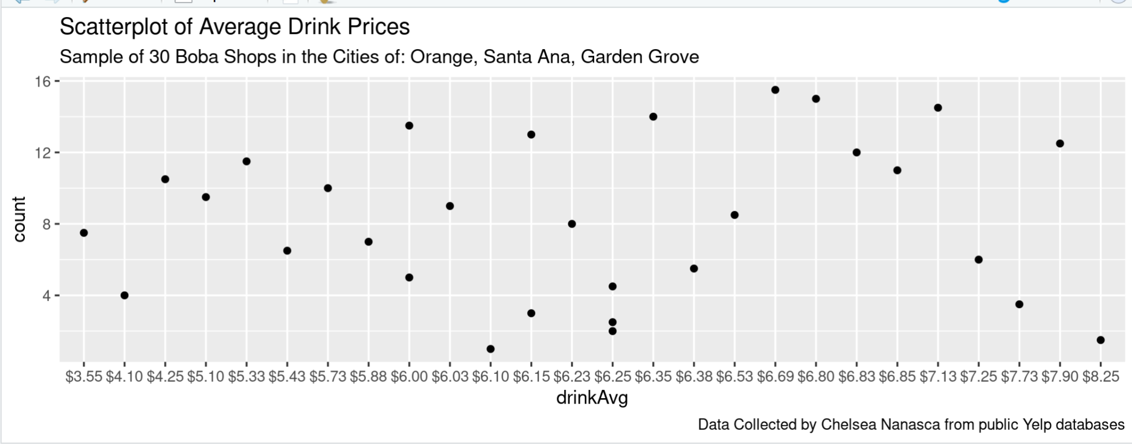

<https://www.geeksforgeeks.org/making-maps-with-r/>

<https://www.youtube.com/watch?v=AgWgPSZ7Gp0>

4/28/25

* Used the function:=SORT({UNIQUE(FLATTEN(N:R)),COUNTIFS(N:R,UNIQUE(FLATTEN(N:R)))}, 2, FALSE)  
    
  In google sheets to get the **top five boba flavors**

5/1/25

* Made a new Google Sheet with all of the top boba flavors, and put them into one column to make a new data visualization: 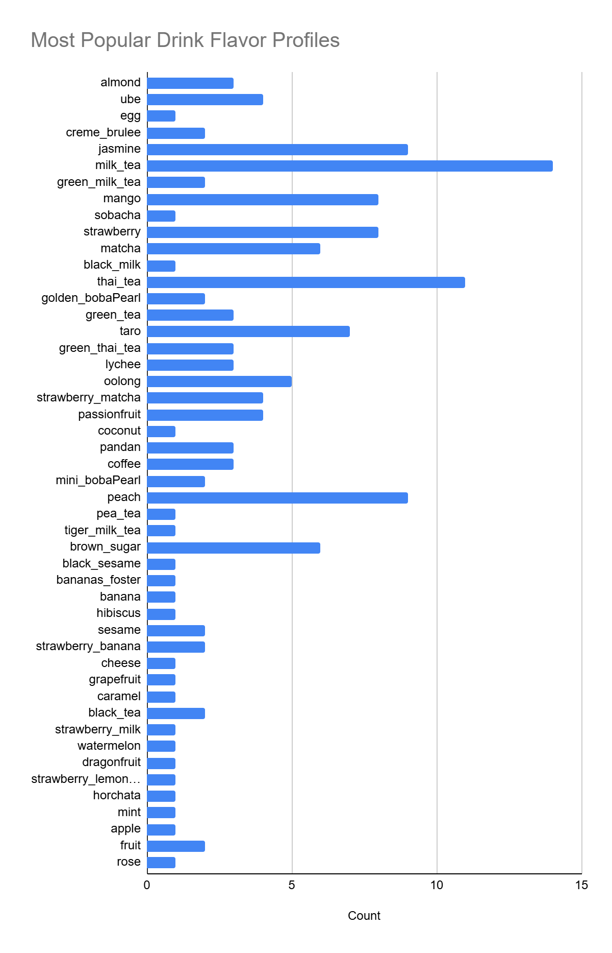

Used the code to install a maps package.

install.packages(c("sf",

+ "mapdata","maps"))

install.packages(c("tidyverse", "tidygeocoder", "ggmap"))

library(tidyverse)

library(tidygeocoder)

library(ggmap)

library(sf)  
library(mapdata)  
library(maps)

Making a dataframe for the addresses, and using the osm public package to translate the addresses into coordinates.

**address_df <- data.frame(address = address_df)**

**>**

**> library(tidygeocoder)**

**>**

**> coords <- tidygeocoder::geocode(address_df, address = "address", method = "osm")**

Combined the coordinates with the dataframe

address_df <- cbind(address_df, coords)

Created this Map:

library(leaflet)

leaflet(address_df) %>%

addTiles() %>%

addMarkers(

lng = ~long,

lat = ~lat,

popup = ~address

)

Image 1: Overview of all of the boba shops

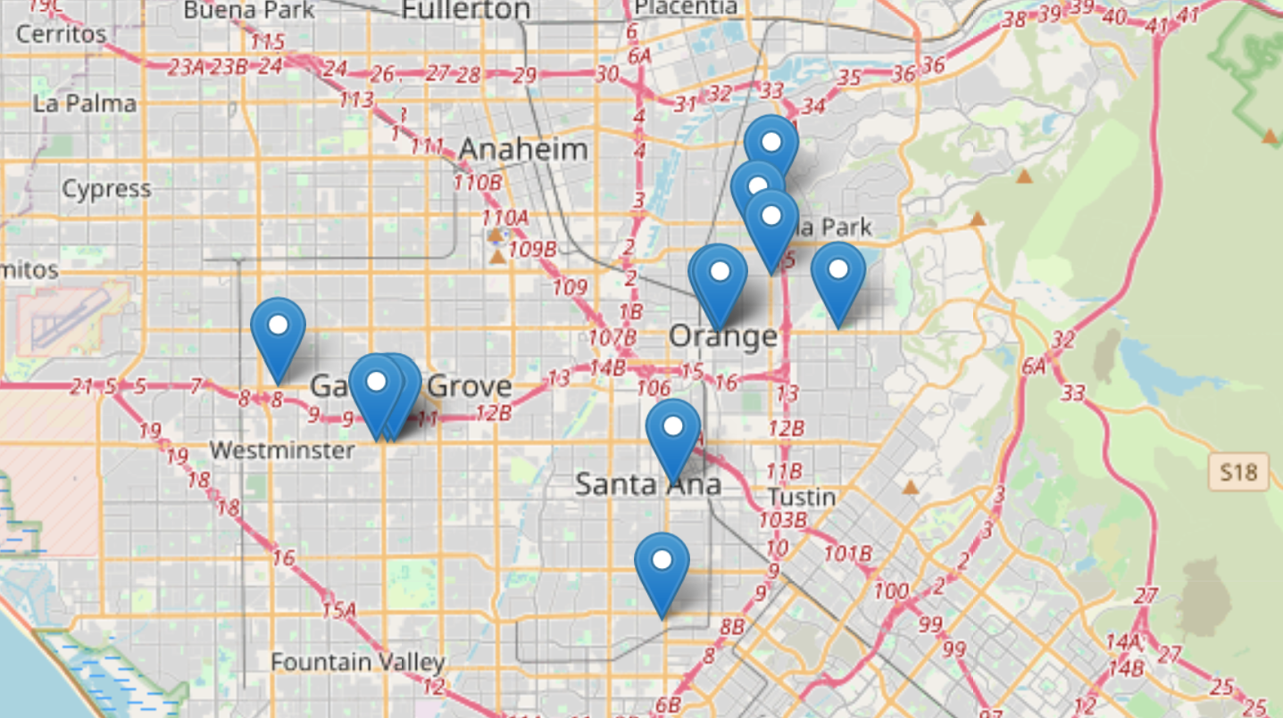

Image 2: Zoomed in shot of Garden Grove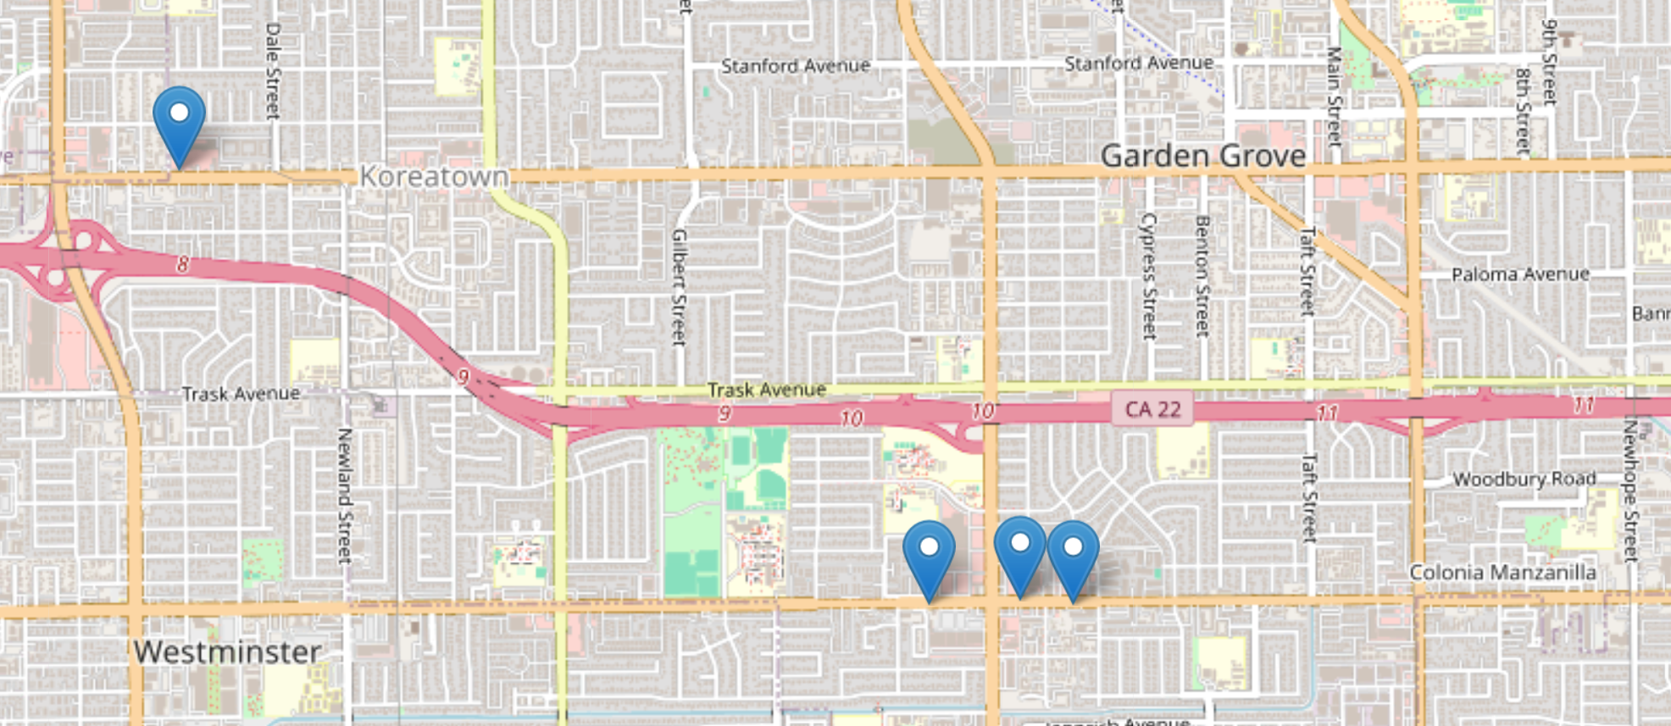

Image 3: Zoomed in shot of Santa Ana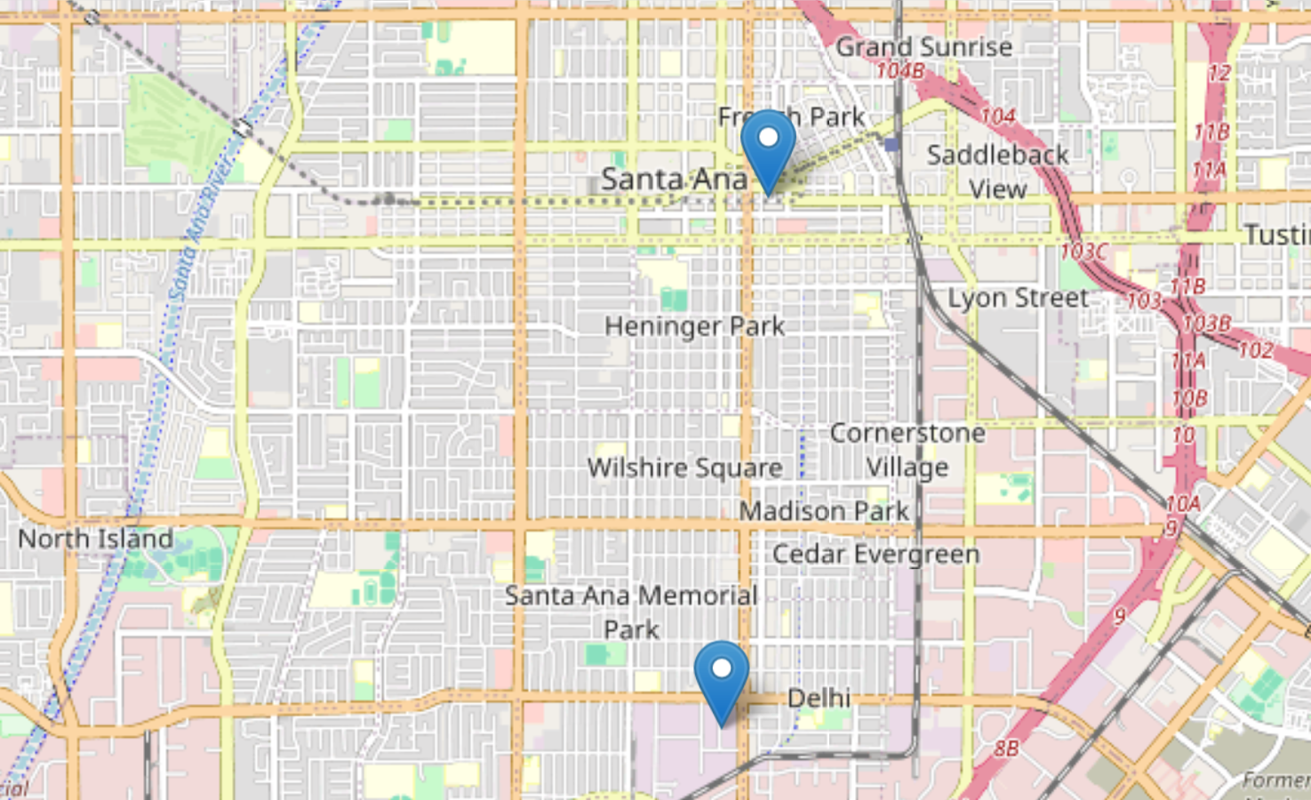

Image 4: Zoomed in Shot of Orange

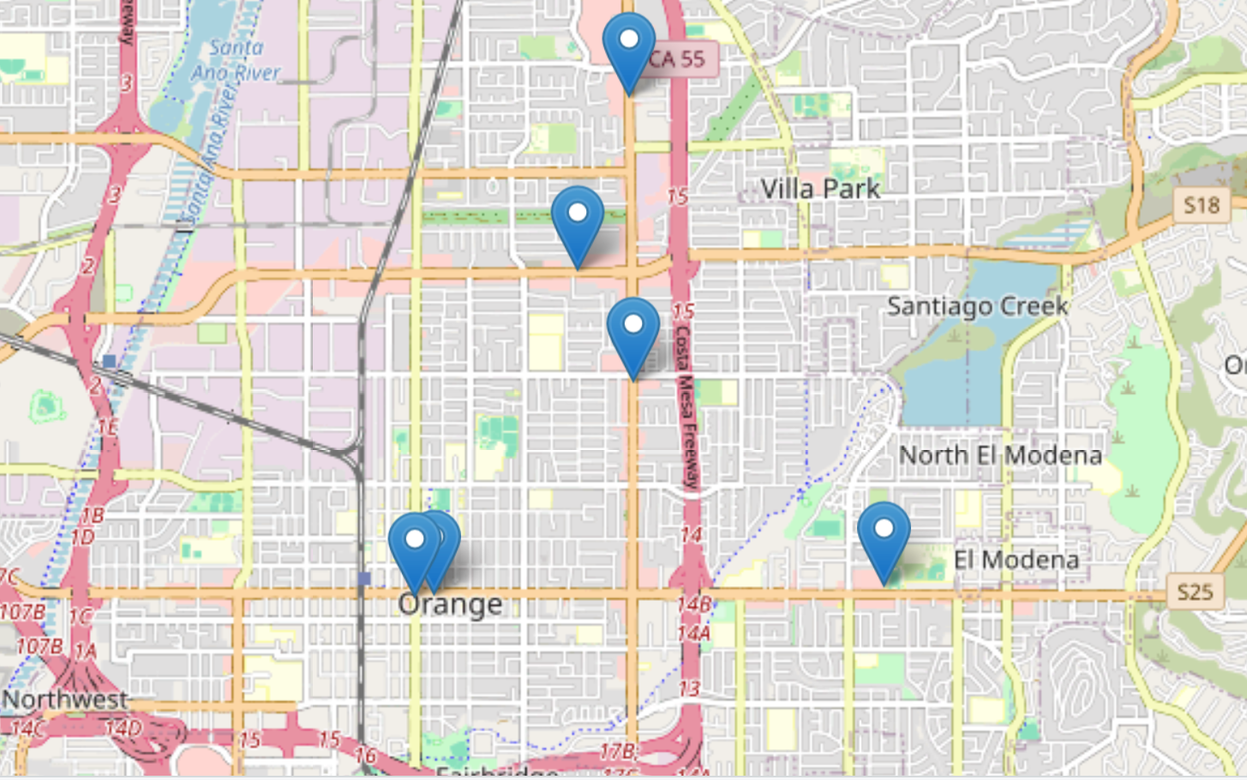

Used the following code to generate a graph of the cheapest snacks.

**boba_Shops$y_values <- seq(from = 1.00, to = 15.50, by = 0.5)**

**> ggplot(boba_Shops)+geom_point(mapping=aes(x= cheapestFood, y=y_values))+labs(title = 'Scatterplot of Cheapest Snacks', subtitle = 'Sample of 30 Boba Shops in the Cities of: Orange, Santa Ana, Garden Grove', caption = 'Data Collected by Chelsea Nanasca from public Yelp databases')**

>

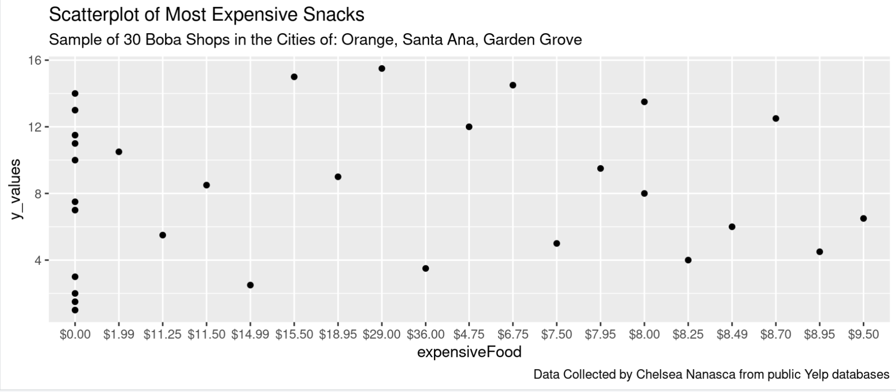

Used the following code to generate a graph of the most expensive snacks.

**ggplot(boba_Shops)+geom_point(mapping=aes(x= expensiveFood, y=y_values))+labs(title = 'Scatterplot of Most Expensive Snacks', subtitle = 'Sample of 30 Boba Shops in the Cities of: Orange, Santa Ana, Garden Grove', caption = 'Data Collected by Chelsea Nanasca from public Yelp databases')**

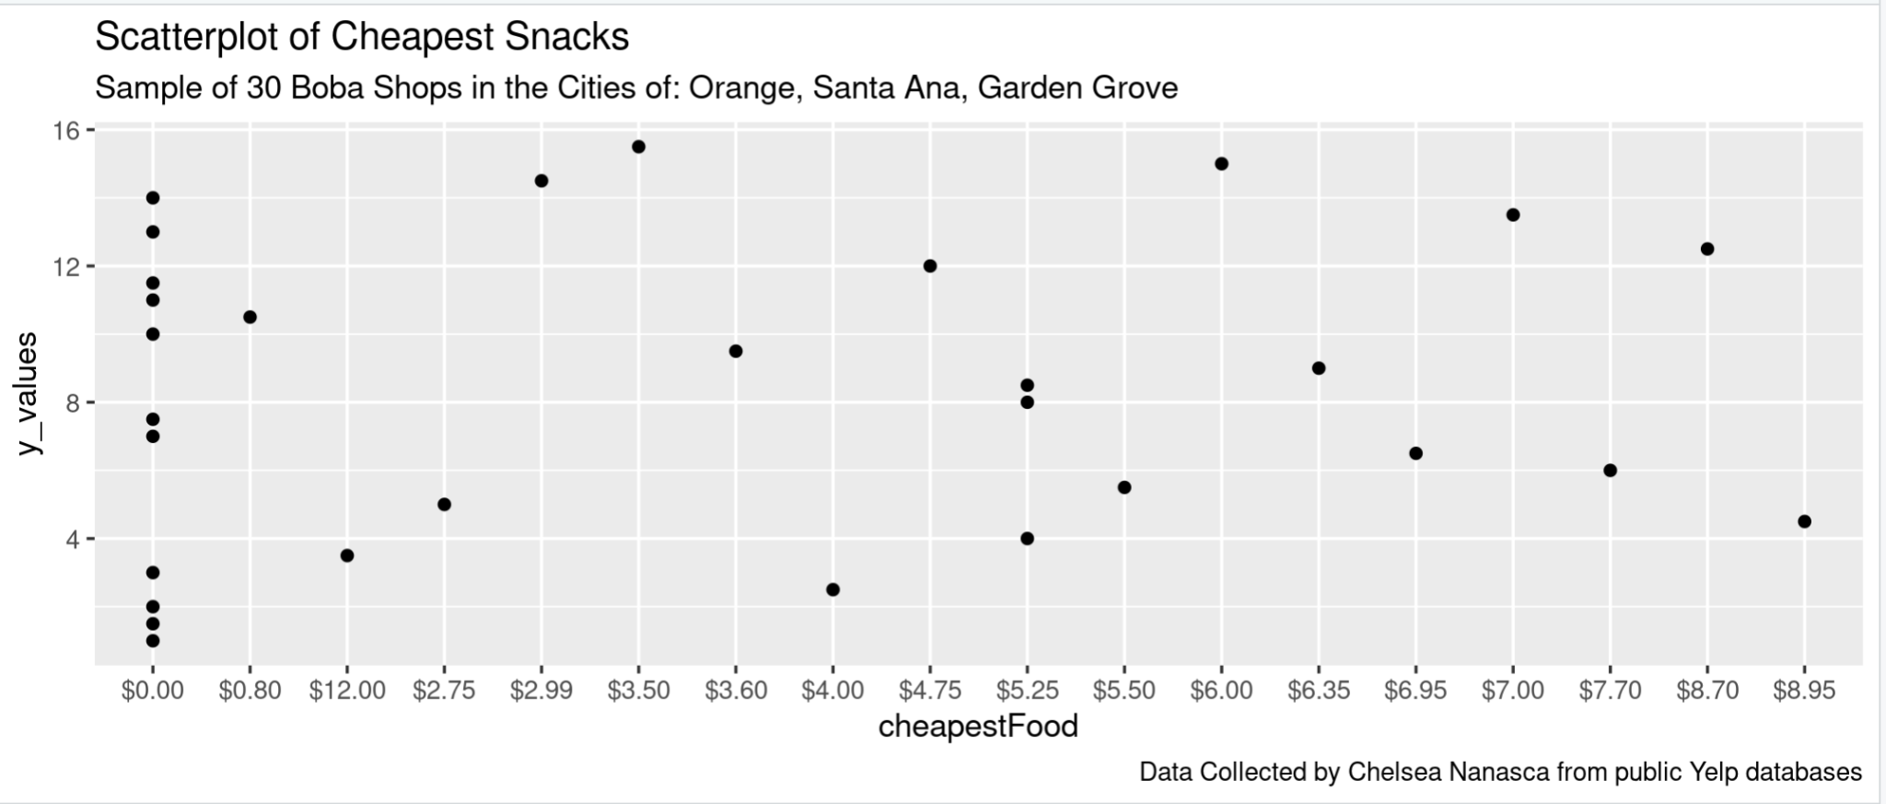

Made a Scatterplot of Average Snack Prices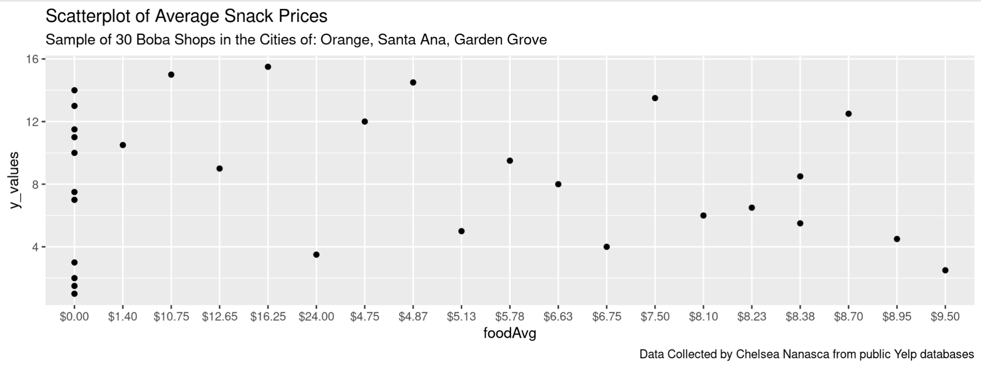Made a table of available retail spaces in the city of Orange